‘’’ Henry Chan ‘’’

import sqlite3

from prettytable import PrettyTable

def connect_db():

conn = sqlite3.connect(r'c:\sqlite\db\bank.db')

return conn

def list_all_branches(conn):

cursor = conn.cursor()

cursor.execute("SELECT * FROM branch")

headers = [description[0] for description in cursor.description]

table = PrettyTable(headers)

rows = cursor.fetchall()

for row in rows:

table.add_row(row)

print(table)

def count_accounts_greater_than(conn, amount):

cursor = conn.cursor()

cursor.execute("SELECT COUNT(*) FROM account WHERE balance > ?", (amount,))

count = cursor.fetchone()[0]

print(f'Number of accounts with balance greater than {amount}: {count}')

def find_customers_with_deposit(conn):

cursor = conn.cursor()

cursor.execute("""

SELECT customer.customer_name, customer.customer_street, customer.customer_city,

depositor.account_number, account.balance

FROM customer

JOIN depositor ON customer.customer_name = depositor.customer_name

JOIN account ON depositor.account_number = account.account_number

""")

headers = [description[0] for description in cursor.description]

table = PrettyTable(headers)

rows = cursor.fetchall()

for row in rows:

table.add_row(row)

print(table)

def add_new_customer(conn, customer_name, customer_street, customer_city):

cursor = conn.cursor()

cursor.execute("""

INSERT INTO customer (customer_name, customer_street, customer_city)

VALUES (?, ?, ?)

""", (customer_name, customer_street, customer_city))

conn.commit()

print(f"New customer {customer_name} added successfully.")

def add_new_account(conn, account_number, balance):

cursor = conn.cursor()

cursor.execute("""

INSERT INTO account (account_number, balance)

VALUES (?, ?)

""", (account_number, balance))

conn.commit()

print(f"New account {account_number} with balance {balance} added successfully.")

def link_customer_account(conn, customer_name, account_number):

cursor = conn.cursor()

cursor.execute("""

INSERT INTO depositor (customer_name, account_number)

VALUES (?, ?)

""", (customer_name, account_number))

conn.commit()

print(f"Linked customer {customer_name} to account {account_number}.")

def update_customer_address(conn, customer_name, new_street, new_city):

cursor = conn.cursor()

cursor.execute("""

UPDATE customer

SET customer_street = ?, customer_city = ?

WHERE customer_name = ?

""", (new_street, new_city, customer_name))

conn.commit()

print(f"Address for customer {customer_name} updated successfully.")

def make_deposit(conn, customer_name, account_number, deposit_amount):

cursor = conn.cursor()

cursor.execute("""

UPDATE account

SET balance = balance + ?

WHERE account_number = ? AND account_number IN (

SELECT account_number FROM depositor WHERE customer_name = ?

)

""", (deposit_amount, account_number, customer_name))

print(f"{cursor.rowcount} rows updated.")

conn.commit()

print(f"Deposit of {deposit_amount} made to account {account_number} of customer {customer_name}.")

def list_all_customers(conn):

cursor = conn.cursor()

cursor.execute("SELECT * FROM customer")

headers = [description[0] for description in cursor.description]

table = PrettyTable(headers)

rows = cursor.fetchall()

for row in rows:

table.add_row(row)

print(table)

def main():

conn = connect_db()

while True:

print("""

1. List all branches

2. Count accounts with balance greater than specific amount

3. Find customers with deposit

4. Add new customer

5. Update customer address

6. Make a deposit

7. List all customers

0. Exit

""")

choice = input("Enter your choice: ")

if choice == '1':

list_all_branches(conn)

elif choice == '2':

amount = int(input("Enter the amount: "))

count_accounts_greater_than(conn, amount)

elif choice == '3':

find_customers_with_deposit(conn)

elif choice == '4':

name = input("Enter customer name: ")

street = input("Enter customer street: ")

city = input("Enter customer city: ")

add_new_customer(conn, name, street, city)

account_number = input("Enter new account number: ")

balance = float(input("Enter initial balance: "))

add_new_account(conn, account_number, balance)

link_customer_account(conn, name, account_number)

elif choice == '5':

name = input("Enter customer name: ")

new_street = input("Enter new street: ")

new_city = input("Enter new city: ")

update_customer_address(conn, name, new_street, new_city)

elif choice == '6':

name = input("Enter customer name: ")

account_number = input("Enter account number: ")

deposit_amount = float(input("Enter deposit amount: "))

make_deposit(conn, name, account_number, deposit_amount)

elif choice == '7':

list_all_customers(conn)

elif choice == '0':

break

else:

print("Invalid choice. Please choose a valid option.")

if __name__ == "__main__":

main()

The above Python code is a banking system that allows users to perform various operations such as listing all branches of the bank, counting accounts with balance greater than a specific amount, finding customers with deposits, adding new customers to the bank's database, updating customer addresses in the database and making deposits. The code uses a database connection to store and retrieve data from the bank's database.

The main function of the code contains a while loop that displays a menu of options for the user to choose from. Depending on the user's selection, different functions are called to perform specific operations. For example, if the user selects option 1 from the menu, then the function list_all_branches is called which retrieves all branch information from the database and displays it in a table format using PrettyTable library.

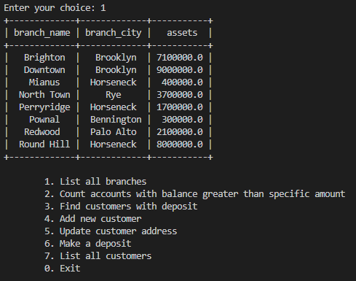

Similarly, if the user selects option 4 from the menu to add a new customer to the bank's database then they are prompted to enter their name and address which is then added to the database using add_new_customer function.

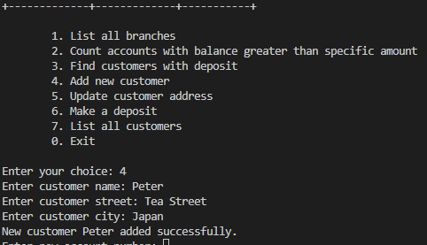

Overall this Python code provides an efficient way for banks to manage their customers' accounts and transactions by automating various banking operations.

